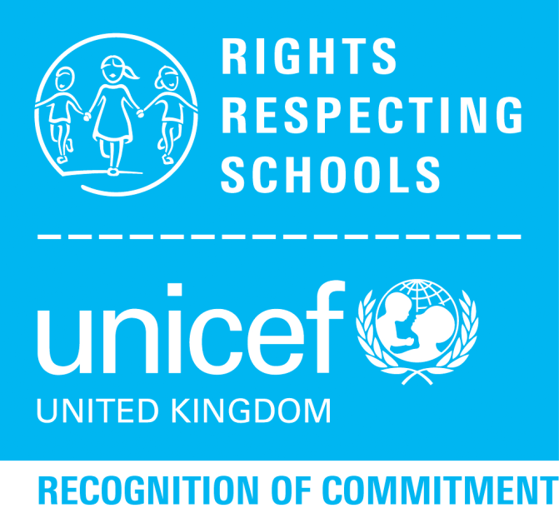
Rights
Respecting
Schools

Where are we going?
Our next steps will be to...

- …raise awareness and of Rights Respecting Schools within our school, parent and local community.
- …continue to focus on Rights Respecting School ideas within assemblies and school calendar of events.
- …develop knowledge and understanding of the UNCRC Articles through the curriculum focusing on Health and Wellbeing and one other area.
- …create Class Charters using the language associated with Rights respecting Schools and the relevant UNCRC Articles.
- …review school policies in line with Rights Respecting Schools and relevant UNCRC Articles

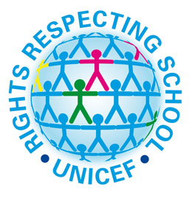

Where are we now?
We are pleased to say we are on our way to becoming a Rights Respecting School and have gained our Recognition of Commitment status.

How have we achieved this?
- Rights Respecting School in part of our School Improvement Plan.
- A number of staff have taken part in training courses to raise awareness and develop knowledge of Rights Respecting Schools.
- Young Rotarians pupil group has been set up to support school and community work.
- Auditing where we are as a school and making our Action Plan for further work.

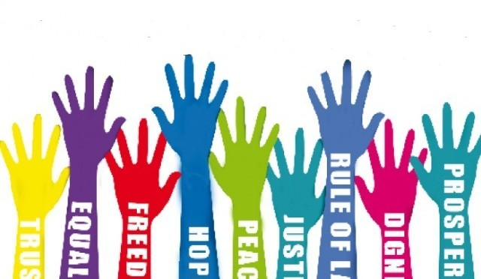
Cluny Primary School
Parent Information

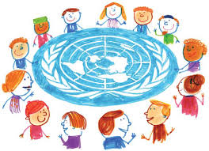
What is a Rights Respecting School?
Rights Respecting Schools (RRS) status is awarded by UNICEF - United Nations International Children’s Emergency Fund. UNICEF work hard to help children and their families all over the world, ensuring that all children can enjoy their rights identified in the UNCRC.

What is the UNCRC?
UNCRC stands for United Nations Convention on the Rights of the Child. These rights are a list of promises to every child to keep them safe. The 54 promises used to make sure that all children are treated fairly and looked after properly. This international agreement has four guiding principles.

Article 2 - All the rights guaranteed by the UNCRC must be available to all children and young people without discrimination.

Article 3 - The best interests of the child or young person must always come first.

Article 12 - The views of children and young people must be considered and taken into account in all matters affecting them.

Article 6 - All children and young people have the right to life, survival and development.

Every child has the right:
- to survive
- to develop to be the best they can
- to protection from harmful influences, abuse and exploitation
- to participate fully in family, cultural and social events

Where our School Aims Link with the UNCRC
- We prepare our pupils for future roles by fostering positive, responsible and considerate attitudes, respecting the values and rights of all.

Article 1 – Everyone under the age of 18 has all the rights in the convention
Article 3 – The best interests of the child must be top priority in all things that affect children.
Article 42 – Governments should make the Convention known to children.

Do our values and aims support the work of Rights Respecting Schools?
The aims of both Rights Respecting Schools and Cluny Primary help children to achieve their potential to become responsible and global citizens.

What is taught through Rights Respecting School helps children learn respect for self and others, develop critical thinking skills and develop knowledge and understanding to make informed decisions about local and global issues.

Where our School Aims Link with the UNCRC
2. We foster a climate of high achievement through enjoyable and stimulating learning experiences, encouraging each child to reach their potential.

Article 2 – The convention applies to everyone, whatever their race, religion or abilities whatever they think or say, whatever type of family they come from.
Article 13 – Every child must be free to have a say in all matters affecting them, and to have their views taken seriously.
Article 28 – Every child had a right to an education. Primary education must be free. Secondary education must be available for every child. Discipline in schools must respect children’s dignity. Richer countries must help poorer countries achieve this.

3. We aim to provide our pupils with a broad general education, building strong partnerships with parents and the wider community.

Article 23 – A child with a disability has the right to live a full and decent life with dignity and independence, and to play an active part in the community. Governments must do all they can to provide support to disabled children.
Article 29 - Education must develop every child’s personality, talents and abilities to the full. It must encourage the child’s respect for human rights, as well as respect for their parents, their own and other cultures, and the environment.
Article 31 - Every child has the right to relax, play and take part in a wide range of cultural and artistic activities.

