Developing
Growth
Mindset
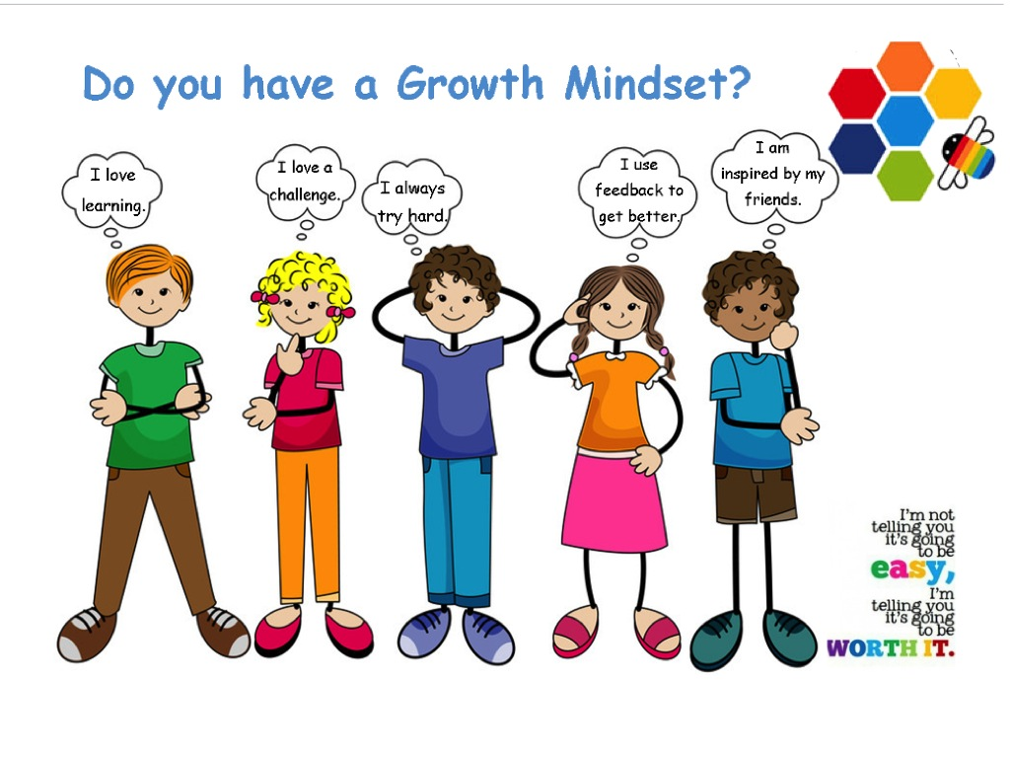

Cluny Primary School

Celebrating Happiness, Health and Ambition for Learning
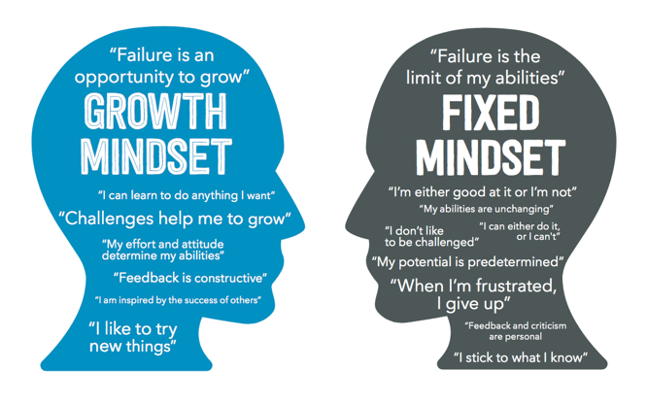
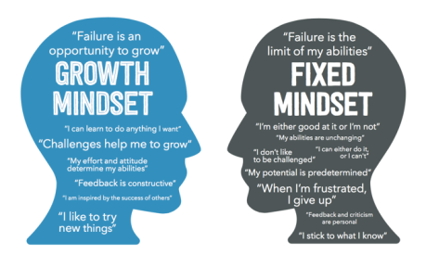
“In a fixed mindset students believe their basic abilities, their intelligence, their talents, are just fixed traits. They have a certain amount and that’s that, and then their goal becomes to look smart all the time and never look dumb. In a growth mindset students understand that their talents and abilities can be developed through effort, good teaching and persistence. They don’t necessarily think everyone’s the same or anyone can be Einstein, but they believe everyone can get smarter if they work at it.”
Carol Dweck

Although most people will have a mixture of both mindset in different situations the important work of Carol Dweck highlights the need to help grow children’s Growth Mindset in all they do. By developing a Growth Mindset we are helping children overcome some barriers to learning as the children realise they can grow their ability and tackle challenges.
Children who believe intelligence is a fixed trait (Fixed Mindset) become concerned with how smart they are and will look for tasks that will prove their intelligence. Their actual desire to learn takes a back seat and are more likely to:
- Care a lot about whether people think they are smart or not.
- Avoid learning challenges where they might make mistakes.
- Try to hide mistakes rather than trying to correct them.
- Believe that if they have the ability, they shouldn’t have to try too hard.
- Believe that needing to apply a lot of effort means they are not intelligent.
- Not deal well with frustration and setbacks, sometimes giving up.

Children who believe intelligence can be improved (Growth Mindset) focus on doing so. They tend not to worry about how smart they appear. They are willing to take on challenges and stick to them. Children with a Growth Mindset are more likely to:
- Care about and invest effort in their learning.
- Believe that effort is a positive thing, causing their intelligence to grow.
- Try hard in the face of frustration and failure.
- Look for new learning strategies.
How can we help children develop a Growth Mindset?
- Praise carefully – not for intelligence but for effort.
- Encourage deliberate practice and targeted effort.
- Encourage high challenge tasks to grow those brain cells.
- Discuss errors and mistakes and help children to see them as opportunities to learn and improve.

Intelligence Praise can be changed to Effort Praise
- You’re so clever at …  - You’re so intelligent at …  - You’re lucky you’re gifted at … and it’s easy for you to …  - Don’t worry if you don’t get a great result, did you get a better score than …?  - Ah… you made a mistake, how many times have we told you to get it right first time? | - I’ve noticed the effort you’re putting into …  - All of your hard work and practice is resulting in progress in….  - I’m proud of how committed you have been to learning …  - How do you feel about not getting the result you wanted first time? Are you clear on what you need to do to improve your learning next time?  - You made a mistake, that’s ok, we all make mistakes when we’re learning something new. What can you learn from it, to improve next time?

Effort is the secret to getting better. The more targeted effort you put in, the more you’ll get out. We can help our children to focus on their effort and attention, encourage practice. Regularly recognise this effort with effort praise.
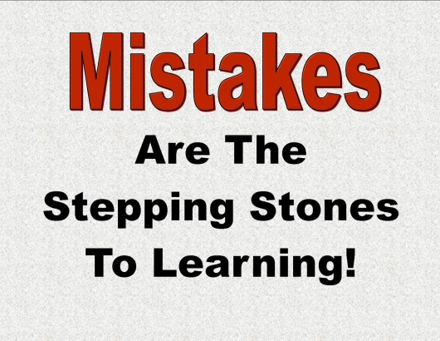
Difficulty and challenging tasks give the opportunity for growth. We create excitement with children as they take on a new challenge and push outside of their comfort zone. Recognise each achievement and point out how much they are learning.
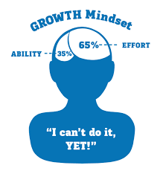
Mistakes are a great opportunity to get feedback, to learn and to grow. We can help our children by seeing that mistakes are feedback (not failure). They provide great opportunity and motivation for growth creating deeper learning as more connections in the brain are made, they are less likely to forget what they have learned. Recognise that when working outside their comfort zone, they are likely to make mistakes that they can learn from.
Yet – A small and empowering word …. YET … shifts thinking from a fixed to a growth state instantly, instead of “I can’t do it.” encourage the children to rephrase and add ‘yet’. “I can’t do it yet,” opens thinking and encourages the children to grow and improve.
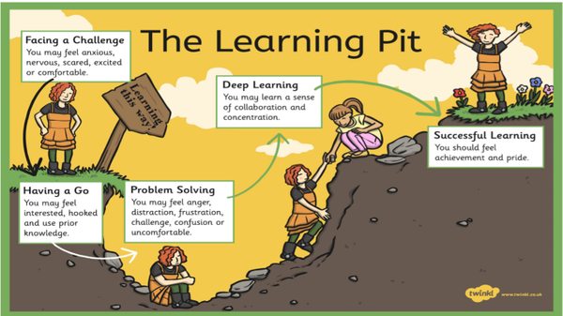
The Learning Pit
The Learning Pit is a tool we use to help children feel comfortable about being faced with challenges. It is an incredible feeling to celebrate when we are being challenged and how we can use both collaboration and the learner qualities to help us achieve our goals.

