Beliefs  - My intelligence and ability are fixed, nature determines my intelligence and ability.  - I have a natural ability for some things and an inability for other things.  - I will always be good at …e.g. maths and always be poor at ….e.g. art. | 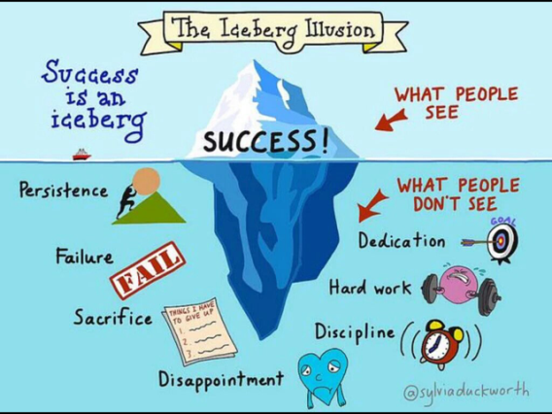 | I apply myself when there is….  - … an opportunity to show off my strengths.  - …a good chance of getting everything right.  - …when I have very little risk of failure.
Priority  - I have to prove myself.  - I have to succeed, especially with little effort, as this proves I am clever.  - I avoid failure of any sort, as this proves I have low ability levels. | Fixed Mindset | Response to Challenge or Failure  - I blame myself or someone else.  - I feel inferior or incapable.  - I try guessing the answers or copy others.  - I seek ego-boosting distractions.
Attitude to Challenging Learning  - I avoid challenge.  - Difficulties will mean I am not as clever as I thought.  - Failure means I am stupid or incapable. | 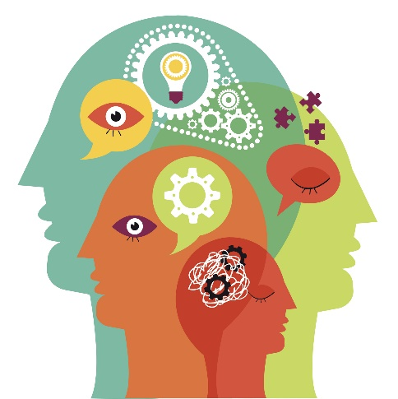 | Mottos  - I believe I am either good at something or I am not.  - If I am really good at something, I won’t need to try.  - If I have to try hard I must have low intelligence.  - I won’t try too hard, that way I have an excuse if things go wrong.

Beliefs  - My intelligence and ability can grow, nature determines my intelligence and ability.  - If I apply myself more, seek help, take risks, change my strategy, then I’ve got a good chance of learning anything and growing my intelligence and talent. |  | I apply myself when there is….  - … an opportunity to learn new understanding and skills.  - …enough challenge to stretch me.  - …an opportunity to try something new.
Priority  - I improve myself.  - If I learn through challenge this will help me to grow my talents.  - I look for challenges that will stretch and help me learn. | Growth Mindset | Response to Challenge or Failure  - There is no blame – I just want to know how to do better next time.  - I am always motivated to have a go.  - I will try various problem solving strategies.  - I will seek advice, support or new strategies.
Attitude to Challenging Learning  - Challenges will help me learn.  - Difficulties are an inevitable part of the learning process.  - Failure means I need to adapt my strategies. |  | Mottos  - Success comes with practice.  - No matter how good I am at something, I can always improve.  - If I have to try, I must be learning.  - I always try hard, that way I have more chance of success.

