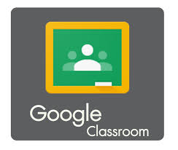

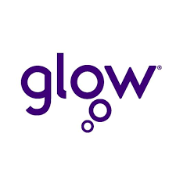
GLOW – DIGITAL LEARNING FOR SCOTLAND
All our pupils have a Glow username and password and it is through Glow that we access Google Classroom. To log in to Glow go to https://www.rmunify.com/ and enter your child’s username and password, then scroll down and click on the Google Classroom tile. Please see the separate help sheet for accessing Glow and Google Classroom which includes information on using the Google Classroom app.

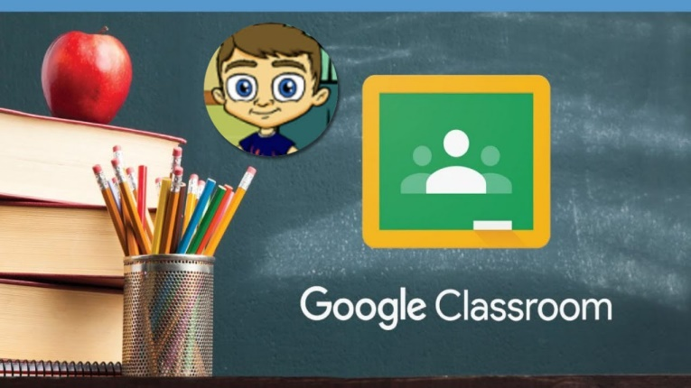
GOOGLE CLASSROOMS FOR EACH CLASS
Every child in the school is now a member of their own Google Classroom, set up by their class teacher. After logging into Glow and accessing Google Classroom you will see a tile with the class name on it.
At the moment, teachers are using their Google Classrooms to share spelling words so children can practise them at home and to share the learning that is happening in classes. This is a useful home-school link and I would encourage everyone to log on and check every week.

MATHS CLUB ON GOOGLE CLASSROOM
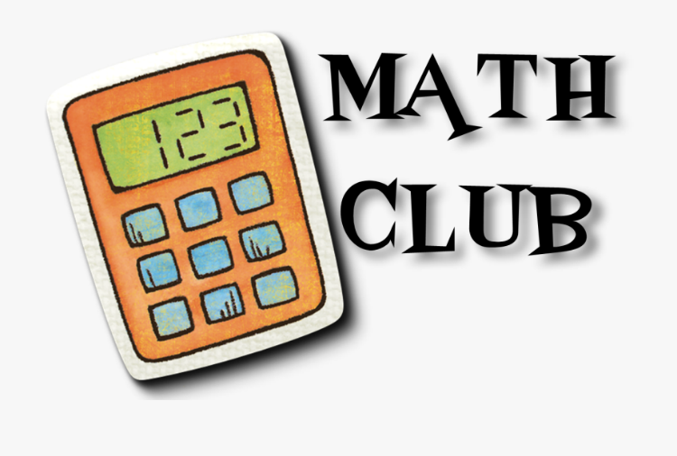
Maths Club on Google Classroom is open to all pupils in P5, P6 and P7. Activities include reinforcement of topics covered in classes; times tables and number bonds practice; problem solving challenges and a range of useful websites.
To join, please login to Google Classroom; click on the plus sign and “join class” then enter the code 7fhbjlt.

ADVICE ON THE SCHOOL WEBSITE
For further advice on supporting your child’s/children’s learning at home please click on the following link:
https://www.cluny.moray.sch.uk/parent_zone/useful_documents/documents_for_parents.html

If you have any difficulties accessing Glow and/or Google Classroom please contact the school and we will be happy to help.

