LITERACY/READING NEWSLETTER
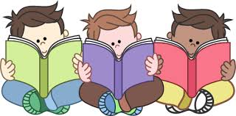

GOOGLE CLASSROOM - READING
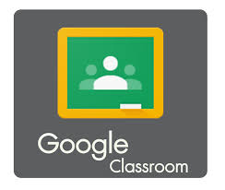
Please join our new ‘Literacy/Reading Google Classroom’ by using the code ponq4fi. In the classroom you will find some video clips on supporting your child’s literacy at home; information on phonics and how to support phonics learning at home; some parents’ guides on reading; recommended reading lists for children in P1 to P7; some useful websites to use with children at home to support their reading development and information on some reading activities and challenges for pupils in P1 to P7.
Please contact the school or send me an email directly – Colin.Young@moray-edunet.gov.uk – if you would like help with accessing Glow and/or Google Classroom.
Please check your child’s own Google Classroom regularly.

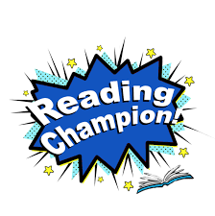
READING CHAMPIONS
This term we will be asking some of our prefects to take on the role of Reading Champions. Their job will be to promote reading throughout the school and they will be given some ownership over the Reading Google Classroom.

READING CHALLENGES
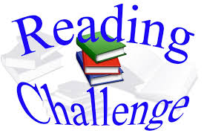
Various challenges are available for P1 to P7 through Google Classroom for pupils to take part in. These include:
- Reading Bingo Cards
- Book Reviews
- 100 Books to Read Before P3/4
- 100 Books to Read Before Leaving Cluny
These challenges are completely voluntary and the children can choose which challenge, if any, they would like to take part in. “Bookworm Badges” will be given to pupils who complete any of the challenges. Please join the Literacy/Reading Google Classroom for more details.

WEBSITES
The following websites are both worth a look. Reading Eggs has a 30 day free trial and is suitable for children from P1 to P7. Oxford Owl is free to join and gives access to many different books to support your child with their reading.
https://readingeggs.co.uk/
https://www.oxfordowl.co.uk/

