Cluny Primary School
Relational Policy
Review Date: January 2025
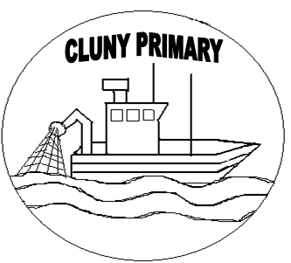

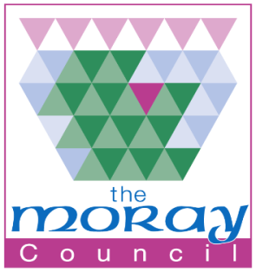


An Overview of Positive Relationships and Relational Approaches
Child’s Planning Meetings

Enhancing the curriculum
Multi-agency approach
Alternative curriculum
GIRFEC
Child at the Centre

Parental Engagement

Ethos and
Values
Values
Restorative Approaches

Communication

Zones of Regulation

Celebrating achievement

House system

Emotion Coaching

“Preparing our learners to achieve, believe and use maths efficiently across learning, life and work”


Effective Interventions

Whole school ethos

Nurture
Consistent approach

Peer Mediation

Targeted Intervention

Solution Focused

Rights of the Child



Rights Respecting Schools

Charters

Rationale:

To provide simple, practical and clear guidelines for staff, pupils and parents that:
- Recognises the expectations, values and ethos of Cluny Primary School.
- Positively encourages and reinforces these expectations, values and ethos.
- Promotes self-esteem and self-respect that builds on the foundations of positive relationships between all.

Aim:

By adopting this policy, Cluny Primary School will:
- Encourage all members of our school community to demonstrate positive, nurturing behaviour through our five key values: Ambition, Honesty, Positivity, Respect and Resilience.
- Ensure we are a Right’s Respecting School by teaching all children about their rights and how actions can affect the rights of others, using the United Nations Conventions on the Rights of the Child.
- Value the importance of developing positive relationships with pupils, parents, members of the community and all external agencies.
- Use our Wellbeing Indicators (SHANARRI) and Scotland’s National approach of ‘Getting it Right for Every Child’ (GIRFEC) to ensure we view each child as an individual and use a holistic approach to their needs. A consistent, solution focused and sensitive approach will be undertaken for each individual child.
- Enable learners to take responsibility for their actions and to demonstrate that consequences are fair, respectful, dignified and provide an opportunity for individuals to repair and reflect.
- Provide consistency and excellence in our approaches to develop as a Nurturing School.

Relational Principles
At Cluny Primary School, we want to promote a nurturing and supportive environment to ensure all members of our school community feel safe, included, respected and able to learn. To create this environment, we adopt the following relational principles:
- Provide a consistent and safe environment
- Maintain a future focus
- Children are understood developmentally
- Understand and demonstrate that all behaviour is communication
- Change is both an opportunity and a challenge
- Collaboration and equity enhance change

Moray Educational Psychology Service: Building Relationships Programme

National Drivers:

The following documents and policies underpin the vision, values and ethos of Cluny Primary School:

- GIRFEC and The Children and Young People (Scotland) Act 2016
- Curriculum for Excellence (CfE)
- National Improvement Framework (NIF)
- Developing the Young Workforce (DYW)
- How Good is Our School 4 (HGIOS4)
- Better Relationships, Better Learning, Better Behaviour 2013
- Respect for All: The National Approach to anti bullying for Scotland’s children and young people (2017)
- Included Engaged and Involved

Our Values and Vision
Our vision at Cluny Primary School is ‘to create a safe and successful learning community that encourages everyone to be the best that they can be.’
We have five key values: Ambition, Honesty, Positivity, Resilience and Respect. To go alongside these and to bring our values to life, we have Value Mascots, which were designed and created by our pupils. These are Andy the Ambitious Ant, Ollie the Honest Octopus, Penelope the Positive Panda, Rosie the Resilient Racoon and Raspberry the Respectful Rabbit. Our Values and our Value Mascots are displayed throughout the school.
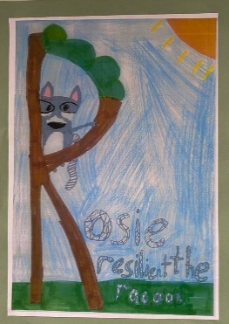
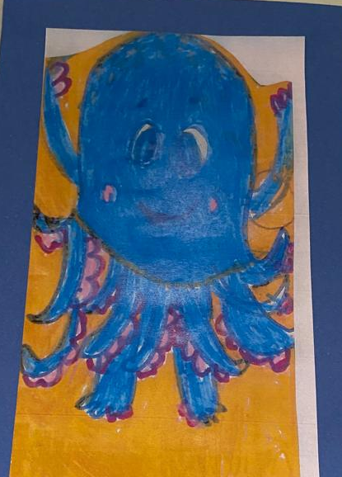
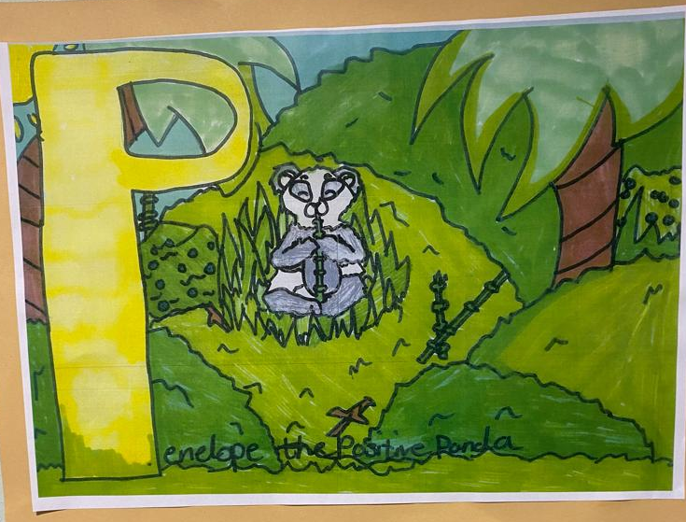
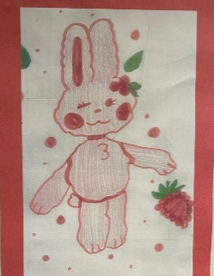
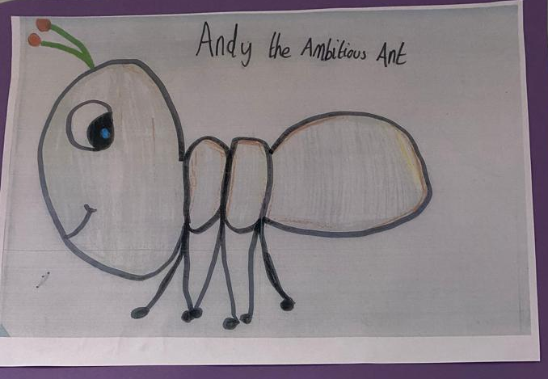

Rights Respecting School
The UN Convention on the Rights of the Child (UNCRC) affirms that every child has a right to education. The purpose of education is to enable children to develop to their fullest possible potential and to learn respect for human rights and fundamental freedoms. At Cluny Primary School we aim to ensure the rights of the child are reflected in our school vision of creating a safe and successful learning community that encourages everyone to be the best that they can. We are a Rights Respecting School, achieving our Bronze Award in July 2022. At the beginning of every school year, each class develops and displays their own class charter where they agree on a class standard linked to the UNCRC with particular emphasis on:
Article 28: Children have the right to an education.
Article 29: Education must develop every child’s personality, talents and abilities to the full.
Article 31: Children have the right to rest, relax and play.
At Cluny Primary, we are aiming to embed a ‘child’s rights’ approach into all aspects of school life through teaching and learning about rights, teaching and learning through rights and teaching and learning for rights.
Nurturing Approaches
The Scottish Government promotes nurture as a key approach to supporting behaviour and emotional wellbeing in Scottish schools. At Cluny Primary School, we understand a positive, nurturing school climate helps develop positive relationships and positive behaviour. We are currently adopting a whole school nurture approach and have a Nurture Room within our school environment. There are Six Principles of Nurture that we follow and consider in all aspects of school life:
- Children’s learning is understood developmentally
- The learning community provides a safe place
- Nurture is essential for wellbeing and learning
- Language is a vital means of communication
- All behaviour is communication
- Transitions offer opportunities and challenges

Zones of Regulation and Emotional Coaching
At Cluny Primary School we encourage all children to share how they feel and help them self-regulate so they are ready to learn. Each class use Zones of Regulation as a visually structured way of supporting children to recognise their feelings. Each morning and throughout the day children are encouraged to select the zone which reflects how they are feeling. Children can move their name/peg to a different zone throughout the day which reflects their feelings at that time. There are four zones, blue is when they may be tired and not feeling well, green is when children are happy and calm, yellow is when children are getting more excited/frustrated and red is when they are finding it difficult to focus/work and are usually not in the right place to learn. On display are also strategies of how to help them move from one zone to another e.g. take 5 breaths, have time out, cuddle a soft toy, have some quiet calm time etc. All staff members wear the Zone of Regulation colours on their lanyards so that we can discuss feelings and relate them to the four zones in any area of the school, including the playground.
Solution Orientated and Restorative approach
At Cluny Primary School, we use a Solution Focused and Restorative approach when dealing with behaviour. Restorative approaches are built on values which separate the person from the behaviour. They promote accountability and seek to repair any harm caused in a situation. Restorative approaches can change the emotional atmosphere in a school and lead to more positive relationships between pupils and between pupils and staff.
Steps | Action
Proactive Strategies for all learners | Emotional Coaching  Zones of Regulations  Daily check ins  Class charters  Modelling behaviours  Recognition of desired behaviour  Effective, genuine feedback  School Values used and referred to – mascots used as a visual
Redirection | Positive engagement and gentle encouragement/support will be used to promote desired behaviour. Emotional Coaching and Zones of Regulation strategies will continue to be used at this point.
Prediction | The pupil will have a conversation on a one-to-one basis with a member of staff in a quiet and calm manner, at the child’s level. The pupil will be made aware of their behaviour and the member of staff will explain what the next step is if this behaviour continues. It will be made clear to the pupil that they still have time to turn their behaviour around. The staff member will communicate clearly their confidence and belief that they can do this. The pupil will then be provided with the opportunity to have some quiet/calm down time to reflect on their behaviour before re-joining in the activity – this may be in a quieter area of the classroom or the quiet zone in the playground, depending on which environment the child is in at the time.
Restorative Practice | Time will be given to repair the situation e.g. if a child has tipped over a box of lego, they would tidy it up with the support of an adult.
Restorative Conversation | A restorative conversation will be held to provide the pupil with the opportunity to reflect on their behaviour and repair the situation with the others involved. A note of this conversation will be recorded by the pupil’s class teacher. Depending on the situation, parents/carers may be called at this point to make them aware of what has happened. During a restorative conversation, the following questions will be discussed:  - What happened?  - What were your thoughts at the time?  - What have been your thoughts since?  - How are you feeling about the situation?  - Who has been affected by what happened?  - How have they been affected?  - What do you need to happen now?  - How can the harm be repaired?
Partnership working with parents | If a pupil has demonstrated violent or aggressive behaviour, there will be a phone call home to parents/carers. If the pupil is consistently showing concerning or inappropriate behaviour, a phone call home will also happen. The purpose of this phone call is to ensure parents/carers are aware of behaviour in school and to identify solutions and strategies to move forward. A member of the Senior Leadership Team or the Class Teacher (depending or the situation) will make this phone call and a note of this will be recorded. If SLT are unable to contact parents/carers through a phone call, an email will be sent instead.  A formal meeting will be held with parents if behaviour continues to be inappropriate or a concern after the initial phone call home. This will take the format of a Child’s Planning Meeting and will involve the pupil voice, parents/carers, class teacher and SLT. This will be a solution orientated meeting which means next steps and action points will be agreed, recorded and monitored. There will then be a follow up meeting to review progress.

Playground Interventions
At Cluny Primary School, it is our priority to ensure the safety of all our pupils. In the playground, if any staff member witnesses a pupil using inappropriate language, demonstrating aggressive or intimidating behaviour or being disrespectful to others, they will issue them with a note to take home. It is expected that parents/carers sign this note as an acknowledgement and it is returned to school the following day. We also have a ‘Quiet Zone’ allocated in the playground for those who want to have a more relaxed break/lunch time as well as some benches on our grassy area for pupils to sit and take some time out. Our playroom is also open at break time and lunch times for those who are finding the playground environment overwhelming and are looking for a more relaxing environment.
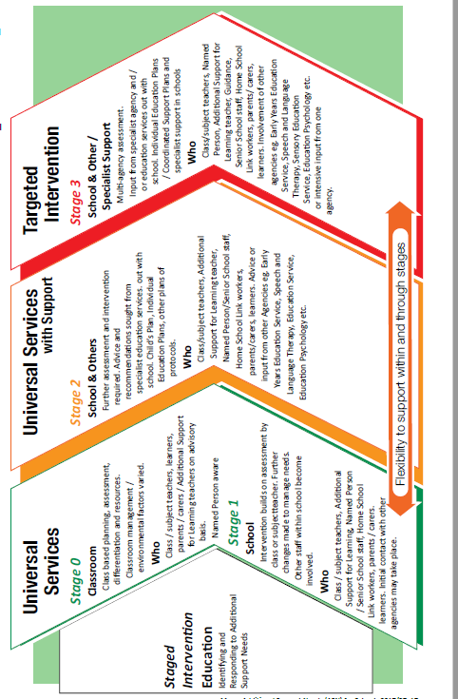
Getting it Right for Every Child
Cluny Primary is an inclusive school that caters learning and teaching, as well as our school environment, around individual needs. We use a Staged Intervention Process to identify, assess and plan for additional support needs, based on the Getting it Right for Every Child (GIRFEC) framework. This enables us to identify children who require specific, tailored interventions and an increased level of targeted support. The Child Planning Process ensures a collaborative approach with the child at the centre. It also ensures that a clear action plan is put in place and that next steps are monitored and reviewed regularly.

Houses
We have four House groups at Cluny Primary School. The names of our Houses were chosen by staff, parents and pupils and reflect our local play parks. Each house also has an allocated colour, which can be worn at House events such as sports day. The Houses and their colours are as follows:
- Linzee Gordon – Green
- Mersons – Blue
- Letterfourie – Red
- Ian Johnston – Yellow
Each house has two House Captains, who act as positive role models and help promote and encourage our school values, visions and aims. All of our Primary Sevens are invited to apply for the post of House Captain and go through an interview process with staff members before undertaking the role. Alongside our House Captains, we have a team of Prefects who also act as role models for our younger pupils and support pupils in the playground environment.
Celebrating Success
At Cluny Primary School, we have a number of strategies to positively encourage and reinforce our school vision and values. These include:
- House Points – house points are collated at the end of each week by our House Captains and Vice Captains. The points for the week are announced at assembly and a running total is displayed in the assembly hall. Every month, our winning house receive a ‘Bonus Break Time’ in the playground. At the end of the academic year, our winning house win a trip to the park that they are named after, for some fun and games. House Points are given out by all members of staff for those who are following our school values, showing kindness to others and who are being a positive role model for others.
- Certificates – we celebrate success by handing out weekly certificates at assembly.
- Sharing Learning – we celebrate success and achievement by sharing our learning with others. At Cluny Primary School, we do this through our classroom and school wall displays, open afternoons which parents/carers are invited to join, parents evenings, parent phone calls and online platforms such as Google Classroom and Twitter.
- Pupil Voice – we have Pupil Committees at Cluny Primary School who are driving forward key aspects of our school improvement plan and ensure we are listening to our learners in order to gain their views, thoughts and ideas. These groups include our Pupil Council and our Rights Respecting Group. We celebrate the achievements of these groups by sharing regular updates of what they have been working on with pupils, parents and staff.
- Class Strategies - Each class will also use their own individual strategies, which cater for their class needs and wants e.g. marble jars, sticker rewards, class dojos.
- Praise – verbal praise, positive written comments and positive notes home are also used throughout the school to recognise and celebrate success
“Every time we relate through quality moments together with a child…we teach them that connection is paramount, that relationships are necessary in order to live well, that relationships can be safe and positive, and can bring safety, comfort, love and joy. The message of health and wellbeing”.
Know Me To Teach Me Louise Michelle Bombèr

Links for further information/reading

Topic | Link
Nurture in Scottish Schools | https://www.nurtureuk.org/what-we-do/whole-school-approach-to-nurture/
Restorative Approach | https://education.gov.scot/parentzone/additional-support/specific-support-needs/social-and-emotional-factors/restorative-approaches/
Rights Respecting School | https://www.unicef.org.uk/rights-respecting-schools/
Emotional Coaching and Zones of Regulation | https://www.zonesofregulation.com/index.html
Getting it Right for Every Child | https://www.gov.scot/policies/girfec/  https://www.gov.scot/policies/girfec/wellbeing-indicators-shanarri/

