Term Four
April to June 2023
Primary 3A
Miss Addison
Dates for your diary:
- 1st May – May Day (school closed to everyone)
- 2nd May – Occasional Day (school closed to everyone)
- 5th May – dress as you please day for bottle or chocolate donation
- 8th May – King’s Coronation (school closed to everyone)
- 11th and 12th May -
In-Service Days (school closed to pupils)
- 20th May – Coffee Morning at the North Church Hall
- 30th June – end of term
P.E. days this term:
Tuesday and Thursday
(Wed 10th, 17th, 24th May at BCHS)
Google Classroom code: yekcm6r

Cluny Primary School
Class Newsletter

It is lovely to see the sunshine make an appearance for the start of our final term this academic year. Whenever possible, we will be doing our PE sessions outside and making use of our outside spaces. Please ensure that your child has water to drink and is wearing appropriate sun protection, especially if they are prone to burning. You will receive an End of Year Report for your child next month and Parents’ Evening arrangements are being finalised for 9th and 10th May. We will inform you as soon as these have been confirmed.

Literacy and Language
This term we will be:
- Learning to write lists in alphabetical order as an introduction to using a dictionary.
- Learing to write using paragraphs and other appropriate punctuation.
- Developing our questionning skills through a variety of fiction texts.

Number Processes and Beyond Number
This term we will be:
- Consolidating and developing reading digital and analogue times, also including timetables and calendars.
- Using knowledge of multiplication tables and practical equipment to solve division calculations.
- Learning to measure using cm and m.
- Learning to identify fractions of a shape and quantity

Other Curricular News
This term we will be:
- Learning about the seas and oceans of the world and sea life creatures.
- Learning about the functions of the major organs in the body and how to keep them healthy.
- Learning about water can change form and exploring different forces we use daily.

Our Class Timetable for Term Four of Academic Year 2022 - 2023:
8.55am – 3.10pm | Events/Activities
Monday | Homework issued, Reading Comprehension, Numeracy, Topic/Art
Tuesday | French, Numeracy, P.E., Reading, Topic
Wednesday | Spelling, Numeracy, Topic/H.W.B.
Thursday | Story writing, Numeracy, P.E
Friday | Spelling test, Handwriting, Reading, Numeracy, Assembly, Golden Time.

This timetable is subject to change. Thank you.

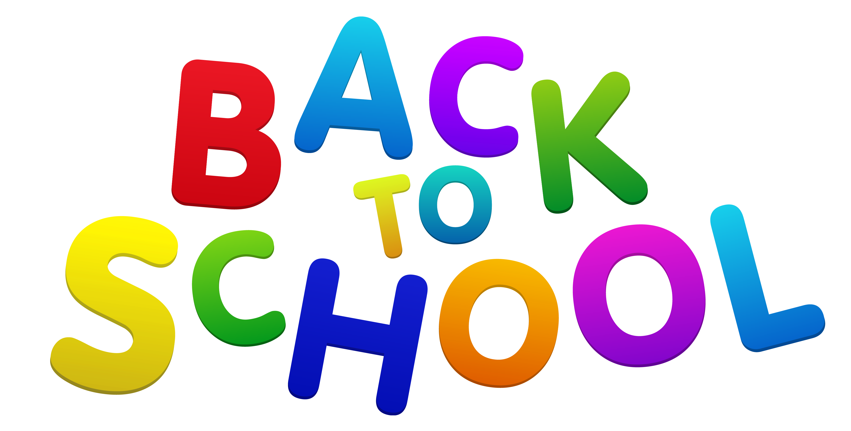







We continue on our journey to become a Rights Respecting School, with a fresh focus on specific UNCRC Articles (Rights) across the school each month.
Right of the Month:
April 2022
Article (Right Number) 16:
Every child has the right to privacy.
May 2022
Article (Right Number) 13:
Children have the right to share freely with others what they learn, think and feel, by talking, drawing, writing or any other way unless it harms others.
June 2022
Article (Right Number) 2:
All children have these rights. No child should be treated unfairly for any reason.

